Logistics and Delivery Performance Analysis
Data Model:
1. Order : order_id , quantity , total_price , …..
2- Customer: Customer_id , Name, residency,
3- Product: product_id , unit_price , stock, warehouse_id, ….
4- Logistics: Logistics_id, order_id, estimated_delivery_date, actual_delivery_date, shipping_cost, warehouse_id
5- Stagging_OrderLines: customer_id , product_id, order_id, quantity, total_price, order_date, shipping_cost
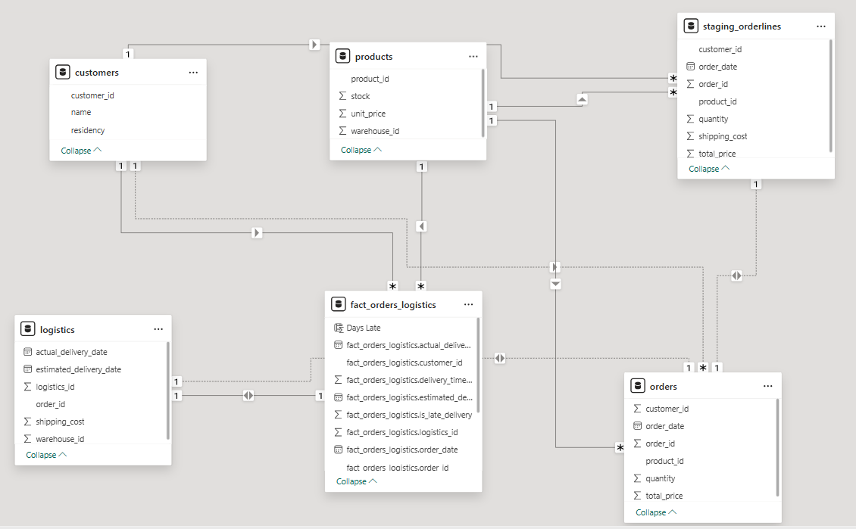

DDL:
-- 1. Customer Table
CREATE TABLE customer (
customer_id SERIAL PRIMARY KEY,
name VARCHAR(100) NOT NULL,
residency VARCHAR(100)
);

-- 2. Product Table
CREATE TABLE product (
product_id SERIAL PRIMARY KEY,
unit_price NUMERIC(10,2) NOT NULL,
stock INT CHECK (stock >= 0),
warehouse_id INT NOT NULL
);

-- 3. Order Table
CREATE TABLE orders (
order_id SERIAL PRIMARY KEY,
customer_id INT REFERENCES customer(customer_id),
product_id INT REFERENCES product(product_id),
quantity INT CHECK (quantity > 0),
total_price NUMERIC(12,2) NOT NULL,
order_date DATE NOT NULL
);

-- 4. Logistics Table
CREATE TABLE logistics (
logistics_id SERIAL PRIMARY KEY,
order_id INT REFERENCES orders(order_id),
estimated_delivery_date DATE,
actual_delivery_date DATE,
shipping_cost NUMERIC(10,2),
warehouse_id INT
-- You could add a CHECK constraint to enforce actual >= estimated,
-- but since NULL is allowed, it requires a custom trigger instead.
);

-- 5. Staging_OrderLines Table
CREATE TABLE staging_orderlines (
customer_id INT REFERENCES customer(customer_id),
product_id INT REFERENCES product(product_id),
order_id INT REFERENCES orders(order_id),
quantity INT CHECK (quantity > 0),
total_price NUMERIC(12,2) NOT NULL,
order_date DATE,
shipping_cost NUMERIC(10,2),
PRIMARY KEY (order_id, product_id) -- Composite PK for line items
);

Insert:
-- Load Customers
COPY customer(customer_id, name, residency)
FROM '/var/lib/postgresql/data/customers.csv'
DELIMITER ',' CSV HEADER;

-- Load Products
COPY product(product_id, unit_price, stock, warehouse_id)
FROM '/var/lib/postgresql/data/products.csv'
DELIMITER ',' CSV HEADER;
-- Load Orders
COPY orders(order_id, customer_id, product_id, quantity, total_price, order_date)
FROM '/var/lib/postgresql/data/orders.csv'
DELIMITER ',' CSV HEADER;

-- Load Logistics
COPY logistics(logistics_id, order_id, estimated_delivery_date, actual_delivery_date, shipping_cost, warehouse_id)
FROM '/var/lib/postgresql/data/logistics.csv'
DELIMITER ',' CSV HEADER;

-- Load Staging_OrderLines
COPY staging_orderlines(customer_id, product_id, order_id, quantity, total_price, order_date, shipping_cost)
FROM '/var/lib/postgresql/data/staging_orderlines.csv'
DELIMITER ',' CSV HEADER;

Extracting Data:
Here we define the Database “e_commerce” in SparkScript.py file:
url = "jdbc:postgresql://host.docker.internal:5432/e_commerce"
properties = {
"user": "external",
"password": "external",
"driver": "org.postgresql.Driver"
}
Reading tables using spark.read:
staging_orderlines_df = spark.read.jdbc(url=url, table="staging_orderlines", properties=properties)

Transformation:
Calculating delivery_time using datediff from actual_delivery_date and estimated_delivery_date.
Handling Null values by computing the difference when both values are not null.
Adding late_delivery column that is 0 or 1 category: 0 if on time & 1 if delayed
When either of the 2 columns is null, then we assume that there is no late_delivery.
logistics_kpi = logistics_df.withColumn(
"delivery_time_delta_days",
when(
(col("actual_delivery_date").isNotNull()) & (col("estimated_delivery_date").isNotNull()),
datediff(col("actual_delivery_date"), col("estimated_delivery_date"))
).otherwise(None)
).withColumn(
"is_late_delivery",
when(
(col("actual_delivery_date").isNotNull()) &
(col("estimated_delivery_date").isNotNull()) &
(col("actual_delivery_date") > col("estimated_delivery_date")),
1
).otherwise(0)
)
Creating fact table from Joining Orders table with Logistics table on order_id and contain delivery_date and is_late_delivery.
fact_df = staging_orderlines_df.alias("s") \
.join(logistics_kpi.alias("l"), col("s.order_id") == col("l.order_id"), "inner") \
.select(
col("s.order_id"),
col("s.customer_id"),
col("s.product_id"),
col("s.quantity"),
col("s.total_price"),
col("s.order_date"),
col("s.shipping_cost"),
col("l.logistics_id"),
col("l.estimated_delivery_date"),
col("l.actual_delivery_date"),
col("l.warehouse_id"),
col("l.delivery_time_delta_days"),
col("l.is_late_delivery")
)

Load:
Loading transformation from spark to hive tables and Running Spark script python file.
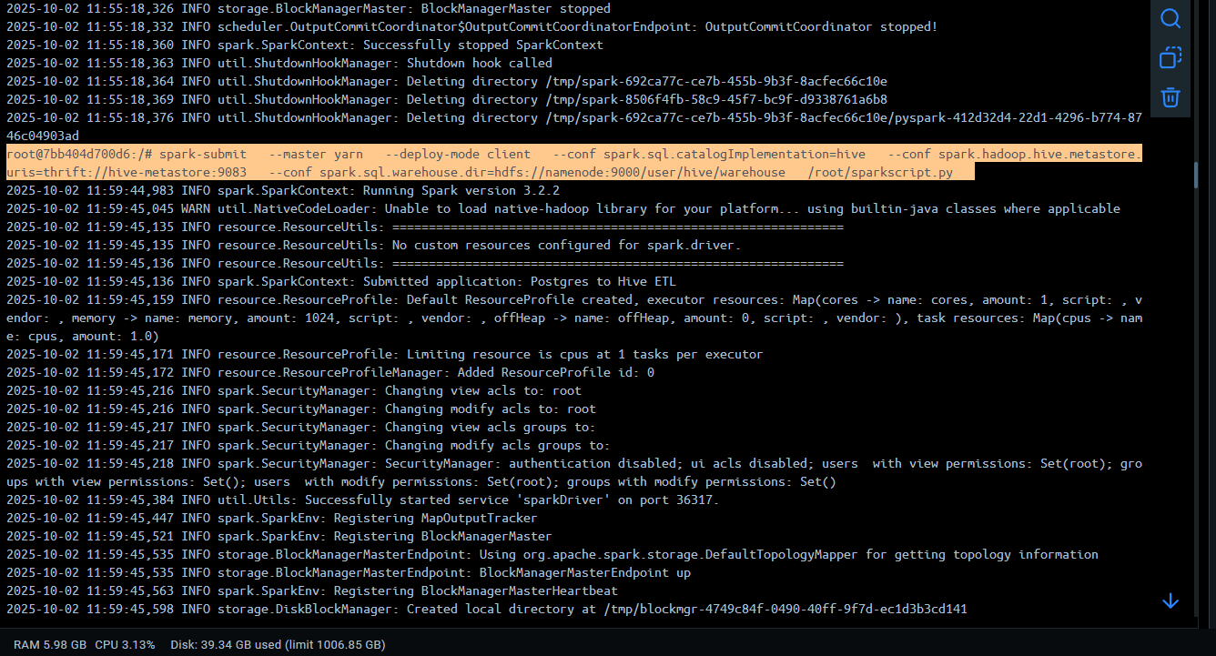
spark-submit --master yarn --deploy-mode client --conf spark.sql.catalogImplementation=hive --conf spark.hadoop.hive.metastore.uris=thrift://hive-metastore:9083 --conf spark.sql.warehouse.dir=hdfs://namenode:9000/user/hive/warehouse /root/sparkscript.py
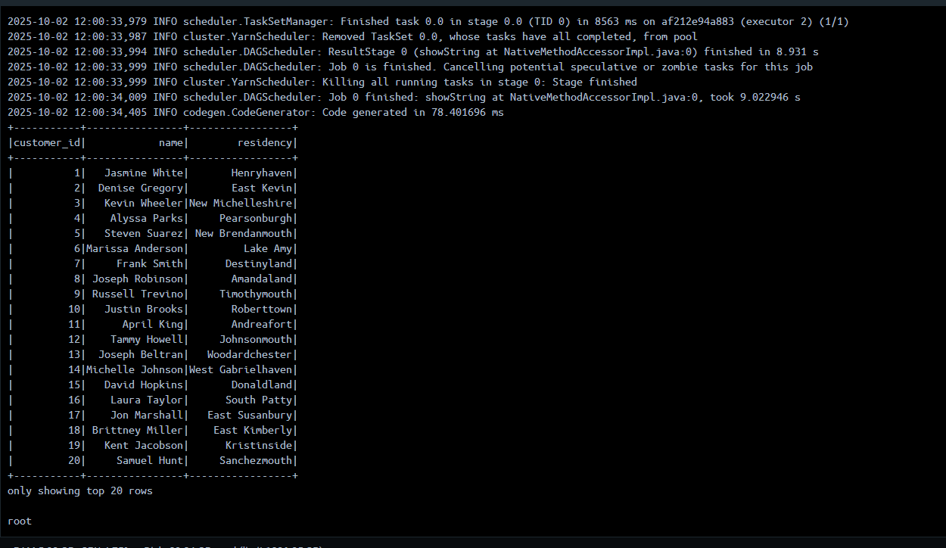

DML Query:
calculate the Average Delivery Time Delta per warehouse_id from fact_logistics.
SELECT warehouse_id, AVG(delivery_time_delta_days) AS avg_delivery_time_delta
FROM fact_orders_logistics
WHERE delivery_time_delta_days IS NOT NULL
GROUP BY warehouse_id ORDER BY avg_delivery_time_delta DESC;
